

Motion energy is correctly termed kinetic energy (you may remember this from last year). It is the energy something posesses if it has movement, for example a bullet has a lot of kinetic energy because it is moving very fast.

This kind of energy is of great interest to athletes as it is how they will win their race! Stability is also an important aspect of sport, whether you are a javelin thrower, a gymnast or a sprinter you will want to maximise stability in a variety of positions.

1. CENTRE OF MASS

The centre of mass of a sportsperson is the single point through which the whole mass of the body can be seen to act. The postion of the centre of mass can affect the balance of an athlete.

Examples of the effect of the centre of mass include; gymnasts whose centre of mass is off centre at inappropriate times can lose their balance; divers with the same problem will have trouble executing a high scoring dive. Weightlifters stand with their feet apart to lower their centre of mass and give them greater stability (ASTA, 2000).

ACTIVITY 1: Determining the Centre of Mass

Materials:
1 Plumb-bob
1 sheet of shapes to cut out
scissors, glue, poster paper

The centre of mass can be determined using a plumb-bob, which consists of a piece of thread with a mass on one end.

Method:

- Cut out the model.
- Push a pin into any point on the model and tie the plumb-bob to the pin.
- Trace the vertical line on the model formed by the hanging thread.
- Push the pin into another point on the model and again trace the vertical line formed by the hanging thread.
- The point where these two lines intersect is the centre of mass. Mark it with a big X
- Now cut out the remainder of the figures, find their centre of mass.
- Place them in correct order to show the changes in the centre of mass of an athlete performing the long jump.
- Glue to the paper provided and write an appropriate heading to explain your series of figures.


2. FORCES

Forces are a very important part of our every day life. While we may not want to execute a triple cartwheel with a round off on our way to school we want to be able to get off the bus safely and manage walking up and down stairs and getting around in general. We experience many different forces nearly all of the time.

A force is a push or a pull which one object applies to another object.

The unit of force is the Newton (N).

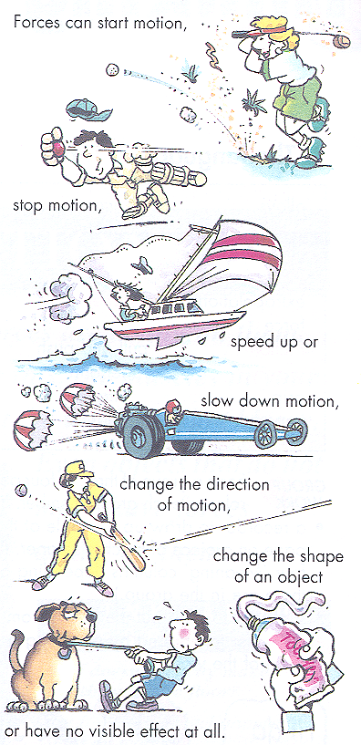

In each of these situations give an everyday example of a;

force that get objects moving. Example………………………….
force that stops moving objects . Example………………………….
force that changes the direction in which an object is moving. Example………………………….
force that stretches an object. Example………………………….
force that might squash, bend, twist or turn objects. Example………………………….
force that prevents movement of objects by balancing other forces acting on the same object. Example………………………….
Some forces act at a distance e.g. gravity (weight), electric forces, magnetic forces.

Some forces act on contact e.g. impact (collision) forces, elastic forces, friction, muscular forces.

⇒ Some important forces that we will look at are WEIGHT and FRICTION.

Mass is the amount of matter in an object (and has the unit of kg).

Weight is a measure of the force of gravity on an object (and has the unit of N).

Thus, mass of an object remains constant no matter where the object is. However, the weight of an object varies, depending on the force of gravity being exerted on the object.

Weight and mass are related according to the equation

weight = mass x "g" where "g" is the force of gravity.

If weight has the unit of N and mass the unit of kg then "g" will have the unit of N/kg (Newtons per kilogram).

On earth "g" has the value of approximately 9.8 Nkg.

Examples
1. a) What is the weight of an apple which has a mass of 0.25 kg?

b) What is the weight of a 500 g object?

2. Gravity is 2 N/kg on the moon.
a) What would be the weight of a 6 kg object on the moon?

If an object is resting ("sitting") on a table, the object exerts a force on the table.

This force F_{w} is equal to the weight of the object.

Examples
1. A book of weight 10 N is resting on a table. What force does the book exert on the table?

2. A box of mass 40 kg is placed on the floor. What force does the box exert on the floor?

ACTIVITY 2: Mass and Weight.

Aim: Investigating the difference between mass and weight in the Earth’s gravitational field.

Equipment:
5.0 N spring balance
a set of slotted 50 g masses
retort stand
bosshead and clamp

Method:
- Pull down the hook until it reads 1 N. Then pull down to 2 N, you will get a feel for how strong a 1 and 2 newton force is.
- Hang the spring balalnce from a rod fixed to a retort stand and adjust the pointer so that is reads zero.
- Attach a 50 g mass to the hook of the spring balance and recod its weight in newtons in the table below.
- Add the masses one at a time, until you have a total mass of 400 g. Record the mass in kilograms nad weight in newtons as you go.

Mass (g) | Mass (kg) | Weight (N)

- Use your results to complete a copy of the graph below.
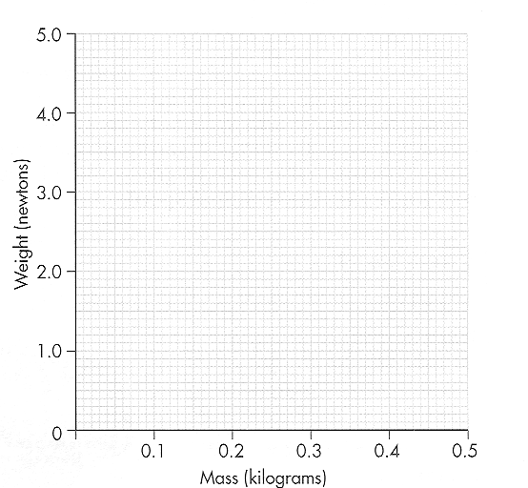
6. Draw a line through the points you have plotted and continue your line to where you think it should be if you measured the weight of a mass of 500 g. ( This process is called extrapolation.)

Questions:

- The gravitational force field on the moon is less than that on earth. Would your items have a different mass on the moon? Explain.

- Would your items have a different weight on the moon? Explain.

- If your items were weighed in a gravitational field that had a strength of 11.5 N/kg then calculate the weight of one of your items in that situation.

Friction is a force which arises whenever one object moves, or tries to move, over another. Friction always acts in the direction opposite to the direction of the motion.

Factors that affect friction are - the nature of the two surfaces in contact
- lubrication between the two surfaces
- the size of the force pushing the two surfaces together.

Example
For each of the following situations, in which would the force of friction between the two surfaces be the greater?

a) a box sliding over a carpet; or the same box sliding over a polished wood floor.

b) a car with bald tyres moving on a road; or the same car with new tyres moving on the same road.

c) a box being pushed over a floor; or a box on rollers being pushed over the same floor.

ACTIVITY 3: Measuring the force of friction.

Aim: To examine the force of friction of different surfaces.

Materials:
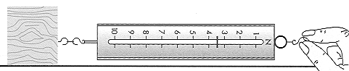
A block of wood
A spring balance
String

Method:
1. Attach the force measurer to the block of wood as shown in the above diagram.

2. Pull the block smoothly over the bench at a constant speed. Measure and record the force required to keep the block moving at a constant speed. Make sure you repeat each trial at least three times.

3. Repeat this for two other different surfaces.

SURFACE TYPE | TRIAL 1 | TRIAL 2 | TRIAL 3 | FRICTIONAL FORCE (N)  (AVEREAGE)
Questions:

- Would the addition of extra mass to the wooden block increase or decrease the sliding frictional force? Would it depend on whether you put the additional block on top or beside the first one? Explain what you think. If you have time, test your ideas.

- Name a sport in which friction is a problem. Explain.

- What reduces the friction between the iceskates and the ice?

PROBLEM SHEET 1 - Forces
1. i) Give two examples of situations in which contact forces are acting.

ii) Give two examples of situations in which forces are acting at a distance.

2. Draw a brick being pulled along by a rope in the space below.

i) What force is slowing up the brick?

ii) How could you make the brick slide along more easily?

3. i) An astronaut weighs 750 N on earth. What is his mass?

ii) If gravity on the moon is 2 N/kg, what is his weight on the moon?

iii) What is his mass on the moon?

4. A body has a mass of 10 kg. What is its weight in Newtons?

5. i) What would be the weight of a 1000 g mass on the moon if gravity is 2 N/kg?

ii) What would it weigh on earth?

iii) What would its mass be on earth?

6. i) What would be the weight of a 500 g object be on the moon where gravity is 2 N/kg?
ii) What would the object weigh on the earth?
iii) What would the mass of the object be on earth?

ANSWERS.

1. i) when two cars collide, when a box is pushed by a person
ii) when two magnets are brought close together, when a charged comb is placed near some dry hair.

2. i) friction
ii) lubricate the surface, smooth the surface, put the block on rollers

3. i) m = = 76.5 kg ii) Fw = m x g = 76.5 x 2 = 153 N

iii) mass = 76.5 kg

4. Fw = 10 x 9.8 = 98 N

5. i) mass = 1 kg Fw = m x g = 1 x 2 = 2 N

ii) Fw = m x g = 1 x 9.8 = 9.8 N iii) Mass = 1 kg

6. i) mass = 0.5 kg Fw = m x g = 0.5 x 2 = 1 N

ii) Fw = m x g = 0.5 x 9.8 = 4.9 N iii) mass = 0.5 kg

3. SPEED

Speed is the rate of change of distance of a body. The average speed is the distance moved per unit time,

Speed(av) = distance
time

Speed is a scalar quantity as it does not require any direction to be named.

The unit of speed is determined by using the formula, that is, dividing the units of length (m) by units of time (s),

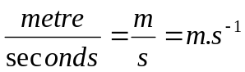 (or m/s )

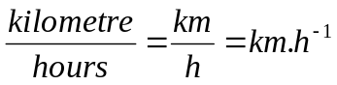 ( or km/h)

Example 1:

A girl can run 600 metres in 2 minutes. What is her average speed in metres per second?

Distance = 600m Average speed = distance
Time = 2 min = 120s time
Average speed = ? = 600
120
= 5m/s
Answer: The girl's average speed is 5m/s

PROBLEM SHEET 2- Speed

- A toy car travels 5 metres in 4 seconds, calculate its average speed.

- What is the average speed of a car which travels 250m in 15 s?

- By how much is a car exceeding a 60 kilometres per hour speed limit if it travels 120 kilometres in 1.5 hours?

- Calculate the average speed in metres per second of a rifle bullet which travels one kilometre in 0.5 seconds.

- What is the average speed of a sprinter who runs 100m in 12.5 s ?

- A body travels 36m in 4s. What is its average speed?

7 Determine the average speed (in kmh-1) of a plane which flies a distance of 720 km in 1.5 hours.

Answers: 1) 1.25m/s; 2) 16.7m/s 3) 20km/h; 4) 2000m/s 5) 8m/s 6) 9m/s 7) 480km/h

Measuring Speed
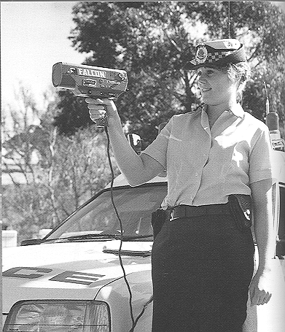

This policewoman is using a laser to detect the speed of on coming cars. Why is it important to measure the speed of cars? In what other situations in measuring speed important?

Ticker timers are useful tools when measuring speed in a classroom situation.

Ticker timers produce dots on a strip of paper at very precise intervals, which allows you to measure the speed of the object that has produced the dots.

The ticker timer produces 50 dots per second. (50 Hz or 50 cycles per second is the frequency of AC electricity). Which means 5 dots in every 0.1 second. This precision allows you to calculate the distance travelled in 0.1 seconds.
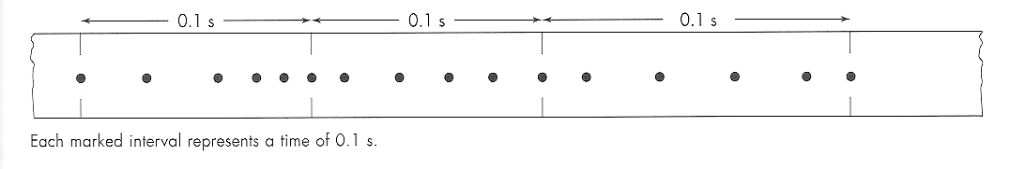

Since, speed is equal to distance divided by time, then you can calculate the speed from a ticker timer tape.

What is the speed of this above sample in m.s⁻¹?

Exercise:
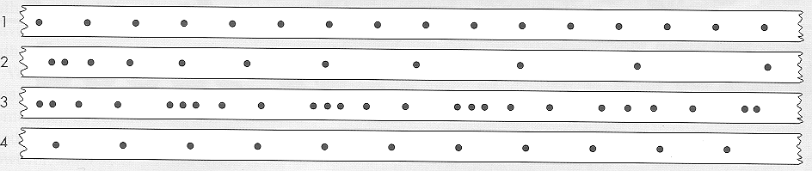

Look at each of the following ticker timer samples and answer the following questions.

- Which tapes show constant speed? _____________________________________

- Which tapes show changing speed? _____________________________________

- What is the difference between tapes 1 and 4? ____________________________

____________________________________________________________________

- How would you describe what happened in tape 2? ________________________

____________________________________________________________________

- What about tape 3? _________________________________________________

____________________________________________________________________

__________________________________________________________________

f) Complete the table below.

Tape Number | Length of 5 intervals (cm) | Speed

How do your measurements compare to what you had originally thought about each sample? _____________________________________________________________

ACTIVITY 4: Ticker Timers and Running Speed

Aim:
To measure your fastest running speed.

Equipment:
Ticker timer
Power supply
6m tape per student
safety pins
rulers

Method:
- Each student should attach one end of the tape to their back with a safety pin. (Make sure the ticker timer is at the same height as the safety pin.)

- Thread the tape carefully through the ticker timer. Another student can turn the ticekr time on, and tell you to go.

- From a standing start run as fast as you can away from the machine in a straight line.

- Once you have completed your trial you can remove your tape and measure off the dots in groups of five.

- Select the three longest groups of dots and, using the same method as you have previously used, calculate your speeds for these groups.

Results:

Stick the sample of you tape here.

Discussion:
1. Were your longest three groups together or separate?

2. Were they near the start or the end of the tape?

- Are there times when your speed was approximately constant?

ACTIVITY 5: Speeding cars.

Aim:
To find an effective way of measuring the speed of 3 cars travelling along the Stirling Highway.

Method:
In a group of 2 you need to decide on a method for how you would like to conduct this experiment. (Think about the variables you need to know in order to calculate speed.)

Write out your method below.
_____________________________________________________________________________________________________________________________________________________________________________________________________________________________________________________________________________________________________________________________________________________________________________________________________________________________________________________________________________________________________________________________________________________________________________________________________________________________________________

Results:

Write your results below.

_____________________________________________________________________________________________________________________________________________________________________________________________________________________________________________________________________________________________________________________________________________________________________________________________________________________________________________________________________________________________________________________________________________________________________________________________________________________________________________
Conclusion:
_______________________________________________________________________________________________________________________________________________________________________________________________________________

Discussion:

1. What improvements could you make to improve the accuracy of this activity?

2. What is the speed limit along the Stirling Highway?

3. Were any of your cars speeding? (You will need to convert your speed into km/h).

PROBLEM SHEET 3 – More speed problems.

1 How long would it take a car travelling at 65m/s to travel a distance of 450m ?
2 A car travels a distance of 250 kilometres at 45 kilometres per hour. How long does it take to cover this distance ?
3 An aircraft travels at 500ms-1 between two towns. How long does it take to cover this distance if the towns are 30 km apart ?
4 How far will a bird fly in 25s travelling with an average speed of 6ms-1 ?
5 A person swims from one end of a pool to the other at an average speed of 1.5ms-1 in 20s. What is the length of the pool ?
6 Determine the distance travelled by a plane in 1 hour if it flies due south with a uniform speed of 90ms-1.
7 How long will it take for a body moving with a uniform speed of 7ms-1 to cover 98m ?
8 A cricket ball is thrown a distance of 90m from the boundary to the wicket at an average horizontal speed of 30ms-1. How long will it take for the ball to reach the wicket?
9 Determine the time taken for a horse running with an average speed of 14ms-1 to complete one circuit of a 840m track.
10 How long will it take to complete a trip from Perth to Kalgoorlie, a distance of 595 km, travelling at an average speed of 70kmh-1 ?
11 A train moving with an average speed of 80kmh-1 takes 0.25 hours to travel from one railway siding to the next. What is the distance between the two sidings ?

PRACTICAL ?????

Ticker timer ?
Measuring traffic ? Playing with traffic ?

INVESTIGATIONS FOR YEAR 9
Physics of Fluids 2000

1 Research the topic of viscosity. Design a simple experiment to compare the viscosity of five different liquids. The liquids you might use are: water, cooking oil, methylated spirit, honey, kerosene. If you want to test any other liquids you can bring them from home.

2 Compare the speed of air flow from a fan as the distance from the fan is changed. You will need to devise an accurate method of measuring the air speed. This may mean building a detection device which measures the relative speeds of air coming from the fan. Collect your data and include tables and graphs in your write up.

3 Construct a model land sail board and test different types of sails to find which is the most effective. A laboratory trolley can be modified to make the land board. You may like to test (a) different sail fabrics OR
(b) different shapes of sails OR
(c) different sail areas.
A fan can be used to provide the wind.

4 Use a laboratory manometer to measure the pressure at various depths of the school swimming pool. You will need to borrow a manometer and modify it so it can be used at the depth of the pool. A conversion table to convert depth to pressure will need to be consulted.

5 Test the bounce of a basketball as it is inflated from “very flat” to considerable pressure. You will need to devise an accurate way of measuring the bounce. Just guessing the height is not good enough. Also you will need to measure the pressure in the ball OR devise a method of indirectly measuring the pressure.

6 Tank test five different shaped objects in water to find which creates the least “drag”. The five objects will be given to you to test. You will need to devise a way of moving the objects in the water so the towing force is constant. When you have collected your data, comment on the suitability of the shapes for boat design.

7 Investigate the pressure exerted by five different types of footwear. You will be provided with the footwear. The investigation is in two parts. In the first instance calculate the pressure a pair of shoes would exert on the ground when the shoes are empty. In the second part of the investigation, calculate the pressure the shoes exert with you in them.

ELECTRICITY 2000
8. Investigate the cost effectiveness of 3 different brands of AA batteries. Set up a method of testing the cells and analyse your results. Include in your investigation the ability of the cells to “recharge” after a period of non use.

9. Construct a lego device which will act as an electro magnet crane. Like the ones used in scrap metal yards. The crane will need to be capable of picking up steel pieces, transporting them a distance and releasing them on to a target. Experiment with different number of coils on the iron core to see how many nails it will pick up. Graph your results and draw any conclusions.

10. Using a reliable source, research how a solar cell produces electricity. Summarise your findings in the introduction to your investigation. When you know how a solar cell works, design a simple device using lego components and connect it to the solar cell. Test the performance of the device when the solar cell is exposed to different intensities of light. Some situations could be: fluorescent lights, sunlight, shaded sunlight, incandescent light etc. In each case measure the current flowing in the circuit and the voltage (“electrical pressure”) across the device you have made. You will need to use a volt meter and an ammeter to take the measurements Record your findings for each situation and make comparisons..

11. Construct an electric heater which is capable of heating 100 mL of water by 50ºC in 5 minutes. Include in your design a rheostat so the current flowing through the circuit can be varied. Do a calculation to find out what length of nichrome wire would be required to heat 50 mL of water by 50 ºC in 5 min. Test the new length of wire to see the result. Comment on the relationship between length of wire and heating ability.

12. Construct a model cell using lead, paper, specimen bottle, lead sulphate and power pack.. Refer to the book, Electricity by Havis, Malcolm and Seddon for hints on how to construct the battery. Charge the battery and connect it to a volt meter and measure the voltage it puts out. Construct a second cell and connect the two cells in series. compare the voltage produced by the cells connected in series with the single cell.

13. Design an electro magnet and use it as a crane. The crane will need to be capable of picking up iron nails, transporting them a distance and releasing them on to a target. Experiment with different number of coils on the iron core to see how many nails it will pick up. Graph your results and draw any conclusions

14. Use a multimeter to measure the resistance in 5 different types of wires. Take measurements of the resistance in the wire for different lengths and different diameters. Tabulate your results and draw graphs to:
(1) illustrate the relationships between resistance and length and
(2) show the relationship between resistance and diameter.

SPEED:

3.0. SPEED

3.1 Speed is the rate of change of distance of a body. The average speed is the distance moved per unit time,

Speed(av) = distance
time

Speed is a scalar quantity as it does not require any direction to be named.

3.2 The unit of speed is determined by using the formula, that is, dividing the units of length (m) by units of time (s),

metre = m = m.s-1 (or m/s )
seconds s

kilometre = km.h-1 ( or km/h)
hour

Example 1:

A girl can run 600 metres in 2 minutes. What is her average speed in metres per second?

Distance = 600m Average speed = distance
Time = 2 min = 120s time
Average speed = ? = 600
120
= 5m/s
Answer: The girl's average speed is 5m/s

3.3 EXERCISES

1 A toy car travels 5 metres in 4 seconds, calculate its average speed.
2 What is the average speed of a car which travels 250m in 15 s?
3 By how much is a car exceeding a 60 kilometres per hour speed limit if it travels 120 kilometres in 1.5 hours?
4 Calculate the average speed in metres per second of a rifle bullet which travels one kilometre in 0.5 seconds.
5 What is the average speed of a sprinter who runs 100m in 12.5 s ?
6 A body travels 36m in 4s. What is its average speed?
7 Determine the average speed (in kmh-1) of a plane which flies a distance of 720 km in 1.5 hours.

Answers: 1) 1.25m/s; 2) 16.7m/s 3) 20km/h; 4) 2000m/s 5) 8m/s 6) 9m/s 7) 480km/h
Example 2:

How long would it take a car travelling a speed of 80m/s to travel a distance of 25m?

Speed (ave) = 80 m/s Average speed = distance
Distance = 25 m time
Time = ? Time = distance
average speed
= 25
80

Answer: The car would take 0.31 seconds

3.4 MORE EXERCISES

1 How long would it take a car travelling at 65m/s to travel a distance of 450m ?
2 A car travels a distance of 250 kilometres at 45 kilometres per hour. How long does it take to cover this distance ?
3 An aircraft travels at 500ms-1 between two towns. How long does it take to cover this distance if the towns are 30 km apart ?
4 How far will a bird fly in 25s travelling with an average speed of 6ms-1 ?
5 A person swims from one end of a pool to the other at an average speed of 1.5ms-1 in 20s. What is the length of the pool ?
6 Determine the distance travelled by a plane in 1 hour if it flies due south with a uniform speed of 90ms-1.
7 How long will it take for a body moving with a uniform speed of 7ms-1 to cover 98m ?
8 A cricket ball is thrown a distance of 90m from the boundary to the wicket at an average horizontal speed of 30ms-1. How long will it take for the ball to reach the wicket?
9 Determine the time taken for a horse running with an average speed of 14ms-1 to complete one circuit of a 840m track.
10 How long will it take to complete a trip from Perth to Kalgoorlie, a distance of 595 km, travelling at an average speed of 70kmh-1 ?
11 A train moving with an average speed of 80kmh-1 takes 0.25 hours to travel from one railway siding to the next. What is the distance between the two sidings ?

Answers: 1) 6.9s; 2) 5.5h; 3) 60s; 4) 150m; 5) 30m; 6) 324km; 7) 14s; 8) 3s; 9) 60s; 10) 8.5h; 11) 20km
Heat - Revision

KINETIC THEORY OF MATTER

1. Label the following as true or false:

a) Solids and liquids are highly compressible.

b) Gases are incompressible.

c) Gases have a fixed shape

d) Solids have a fixed shape

e) Liquids fill all available space

f) Gases do not fill all available space

g) All matter is made up of particles

h) The particles move slower in liquids than in gases

i) The particles move more quickly at higher temperatures

j) The particles move faster in gases than in liquids

k) When a solid is heated and it changes to a liquid, melting has occurred.

l) What a gas is cooled to form a liquid, condensation has occurred.

m) In solids the particles are further apart than in liquids

n) In gases the particle are further apart than in liquids.

DIFFUSION

2. Why can gas be smelt all over the room when just one gas tap is left on?

EXPANSION

3. Complete the following:

a) Solids, liquids and gases expand when .................................................

b) Solids, liquids and gases .................................................... when cooled.

c) Gases expand at a ....................................... rate than liquids when heated.

d) Matter expands when heated because of the ............................................... in motion
of the particles.

e) Different solids expand at ................................................. rates when heated.

2.

4. Draw the apparatus we used to show that

a) liquids expand when heated b) gases expand when heated

5. Explain why a bimetallic strip bends when heated.

TEMPERATURE AND HEAT

6. The temperature of a body is a measure of its ............................. or ...........................

7. Describe how the scale is 'marked out' on a Celsius scale thermometer.

8. Complete the following: 'Celsius temperature' 'Kelvin temperature'

00C ................. K

100C ................. K

.................0C 263 K

-1000C ................ K

-1730C ................ K

..................0C 171 K

-1510C ............... K

9. During a typical Summer day in Perth, the temperature rises from about 20oC in the
morning to about 30oC in the afternoon. That is the temperature rises by about 10oC. What
would this temperature rise be on the Kelvin scale?

10. What phase changes occur during the following?

melting condensation

solidification evaporation

vaporization boiling

3.

11. Wax has a melting point of 51oC and a boiling point of 312oC.
Petrol has a melting point of - 53oC and a boiling point of 71oC.

Complete the following

a) at 100oC, wax would be a ........................... , and petrol would be a ......................

b) at 20oC, wax would be a ............................. , and petrol would be a .......................

c) at 0oC, wax would be a ............................. , and petrol would be a .........................

d) at -100oC, wax would be a ........................ and petrol would be a .........................

12. The following beakers containing water were heated on the same electric hot plate for the times shown
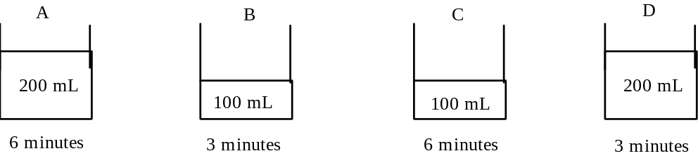

a) Which beaker of water will have the highest temperature after heating?

b) Which beaker of water will have the lowest temperature after heating?

c) What can be said about the temperatures of the remaining two beakers of water?

13. Latent heat is the heat required to cause a c............................ in s...........................
without a change in t.................................................. .
Steam has .................................. latent heat than water does.

14. Explain why when we perspire we feel cooler.

15. The cooling curve for butane gas is drawn below

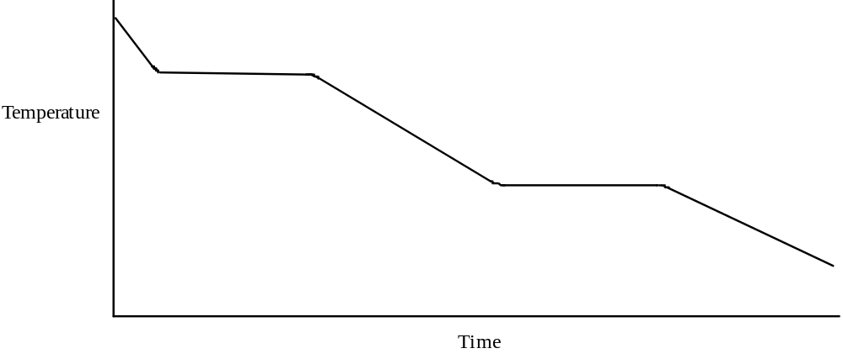

4.

a) Indicate on the graph, the times when changes in state were occurring?

b) What changes in state were occurring at these times?

c) Indicate on the graph the time during which liquid butane solidifying?

d) At time X was the butane a solid, a liquid or a gas?

CONDUCTION OF HEAT

16. The movement of heat along a material, without any transfer of the material itself, is called
................................................

17. Arrange the following materials from best conductor of heat to worst conductor of heat

glass, copper, iron, plastic.

CONVECTION

18. The movement of heat by convection occurs when the l............................. or
g.................... moves around bringing the ...................................... parts to the
heat source.

RADIATION

19. ........................................... is the transfer of heat through space by electromagnetic
waves. Thus, radiation of heat can occur through a vacuum e.g. in space, or through air.

20. All ............................. bodies radiate (emit/give off) heat.

Dark, dull surfaces are .............................. radiators of heat.

Shiny surfaces are ............................................. radiators of heat.

21. Bodies can absorb (take in) radiant heat and so get hotter.

Dark or dull bodies are ...................................... absorbers of heat.

Light coloured or shiny bodies are ....................................... absorbers of heat.

Thus, a black body will become ............................ than a white body when placed in
front of a heat source.

22. Bodies can also reflect (push back) radiant heat.

Dark bodies are .................................... reflectors of heat

Light coloured or shiny bodies are ............................. reflectors of heat.

Year 9 Science Problem Sheet 5. - The Kinetic Molecular Theory of Matter

1. Use the kinetic molecular theory of matter to explain why

a) gases are much more easily compressed (pushed into a smaller space) than liquids.

b) solids are almost incompressible and liquids are only very slightly compressible.

c) a solid has a fixed shape but a liquid and a gas have variable shapes

d) a gas has a variable volume but a solid and a liquid have definite volumes (at constant temperature)

e) gases and liquids can flow (or be poured) but solids cannot.

f) gases and liquids are able to undergo the process of diffusion.

g) if a gas tap is left on in the science room, after awhile everyone in the room can smell gas.

h) gases diffuse quicker than liquids.

i) when heated, gases expand more than liquids which in turn expand more than solids.

j) all gases expand at the same rate when heated.

k) different liquids and different solids expand at different rates.

Year 9 Physics

ANSWERS Heat - Revision

1. a) False b) False c) False d) True e) False f) False g) True h) True
i) True j) True k) True l) True m) False n) True

2. Because the gas diffuses i.e. the gas particles move all around the room, and mix with the air
particles

3. a) heated b) contract c) greater/faster d) increase e) different

4. a) liquids expand when heated b) gases expand when heated
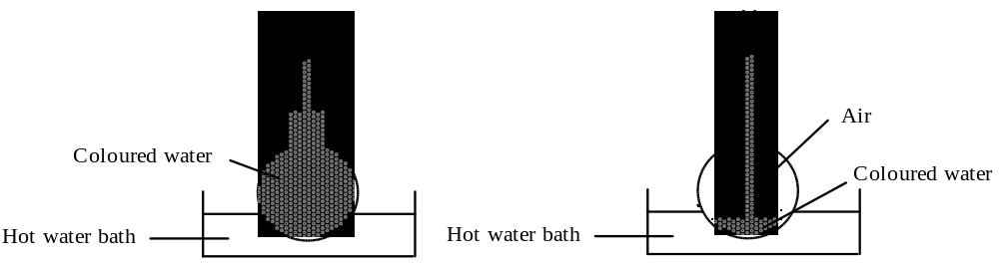

5. Because one metal expands more than the other metal.

6. hotness or coldness

7. - thermomoeter is placed in ice, an the point on the scale where the mercury goes down to is
labelled 0oC,
- thermometer is placed in water and the point to where the mercury goes up to is marked as
100oC,
- the scale is then divided into one hundred even divisions between the 0 and 100 marks.

8. 'Celsius temperature' 'Kelvin temperature'
00C 273 K
100C 283 K
-10 0C 263 K
-1000C 173 K
-1730C 100 K
-102 0C 171 K
-1510C 122K
9. 10 K

10. melting solid -> liquid condensation gas -> liquid
solidification liquid -> solid evaporation liquid -> gas
vaporization liquid -> gas boiling liquid -> gas

11. a) at 100oC, wax would be a liquid , and petrol would be a gas
b) at 20oC, wax would be a solid, and petrol would be a liquid
c) at 0oC, wax would be a solid , and petrol would be a liquid
d) at -100oC, wax would be a solid and petrol would be a solid

2.
12. a) C b) D c) they will be about the same
13. Latent heat is the heat required to cause a change in state without a change in temperature
Steam has more latent heat than water does.

14. because when the perspiration evaporates, it has a cooling effect.

15.
d) At time X, butane is a liquid
16. conduction
17. copper, iron, glass & plastic (these two are about the same)
18. The movement of heat by convection occurs when the liquid or gas moves around bringing
the cold parts to the heat source.
19. Radiation
20. All hot bodies radiate (emit/give off) heat.
Dark, dull surfaces are very good radiators of heat.
Shiny surfaces are poor radiators of heat.

21. Dark or dull bodies are good absorbers of heat.
Light coloured or shiny bodies are poor absorbers of heat.
Thus, a black body will become hotter than a white body when placed in front of a heat
source.

22. Bodies can also reflect (push back) radiant heat.
Dark bodies are poor reflectors of heat
Light coloured or shiny bodies are good reflectors of heat.

Year 9 Science Problem Sheet 5. - The Kinetic Molecular Theory of Matter

1. Use the kinetic molecular theory of matter to explain why

a) gases are much more easily compressed (pushed into a smaller space) than liquids.

b) solids are almost incompressible and liquids are only very slightly compressible.

c) a solid has a fixed shape but a liquid and a gas have variable shapes

d) a gas has a variable volume but a solid and a liquid have definite volumes (at constant temperature)

e) gases and liquids can flow (or be poured) but solids cannot.

f) gases and liquids are able to undergo the process of diffusion.

g) if a gas tap is left on in the science room, after awhile everyone in the room can smell gas.

h) gases diffuse quicker than liquids.

i) when heated, gases expand more than liquids which in turn expand more than solids.

j) all gases expand at the same rate when heated.

k) different liquids and different solids expand at different rates.

